Why?
Membrane Structure
What molecules make up a membrane?

Imagine your bedroom without closets, drawers, shelves, bags or boxes—just a room with a bed. Where would your stuff be? Would you be able to find the things you needed? How efficiently could you get ready for school in the morning? Would all of your school items be together when you sat down to study? The compartments you use in your room—the closet, drawers, etc.—help you organize items by category so that all the items you need to get dressed are in one place. All the items you need for studying are in another place. This compartmentalization improves efficiency. Cells also need organization to improve efficiency. The compartmentalization of cells is achieved by dividing up areas in the cell with membranes. A plasma membrane compartmentalizes internal structures while the cell membrane acts as a boundary between the cell and the external environment.

Model 1 – Phospholipids

H3C

CH3
+
N CH3
CH2
CH2 O

O– P O
O

H2 C HC
O O C
CH2

O

H2 C
CH2 O
C
CH2

H2 C H2 C
H2 C
CH2 CH2
CH2

CH2
H2 C
H2 C H2 C

CH2
CH2 CH2

H2 C
H C
CH2 C
CH2
CH3
CH2

H2 C H2 C

CH2 CH3
H CH2

- Refer to Model 1. Identify at least two organic functional groups in a phospholipid molecule.

- Consider the term phospholipid.
  - What portion of the molecule in Model 1 is responsible for the “phospho-” part of the name?

  - What portion of the molecule in Model 1 is responsible for the “-lipid” part of the name?

- Part of a phospholipid is polar.
  - Circle the portion of the molecule in Model 1 that is polar.
  - Would this portion of the phospholipid mix well with water? Explain your reasoning.

- Part of a phospholipid is nonpolar.
  - Draw a square around the portion of the molecule in Model 1 that is nonpolar.
  - Would this portion of the phospholipid mix well with water? Explain your reasoning.

- Label the regions of the molecule in Model 1 with the phrases “hydrophilic head” and “hydro- phobic tail.”
- Scientists often use a cartoon representation like the one shown below to represent a phospho- lipid. Which portion of the cartoon represents the hydrophilic head of the phospholipid?

- When phospholipids are placed on the surface of water they form a thin layer. Consider carefully which portion of the phospholipid will be in the water and which will be in the air in order to obtain the most stable (lowest potential energy—maximum attractions) system. Draw a cartoon- like representation below to show the proper orientation of three phospholipid molecules on the surface of water.
air

water

8. When a small amount of oil is added to a beaker of water containing phospholipids, the phos- pholipids will surround the oil droplets forming micelles. Use several cartoon representations of phospholipid molecules to show the arrangement or orientation of phospholipids in a micelle.
Water
and oil
oil
water

- Recalling that a beaker of water is three-dimensional, what is the three-dimensional shape of the micelle?

- Phospholipids assemble in layers to make membranes for cells and organelles. Circle the drawing below that represents the most stable (lowest potential energy) assembly of phospholipids where water is both inside and outside of the membrane. (This might be the membrane on a vacuole for instance.) Explain your reasoning.
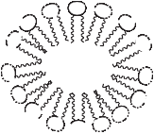
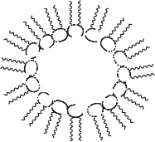
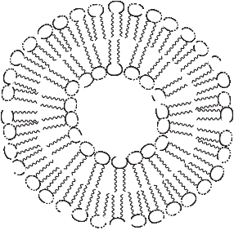

- How do phospholipid molecules lead to compartmentalization of a cell?

Read This!
When phospholipids are added to an aqueous environment (consisting mostly of water) the phospholipid molecules will spontaneously assemble into a phospholipid bilayer where the layers are held together by weak attractive forces between molecules. These structures are often seen in nature as cell and organelle membranes.

- Consider animal cells, which are only bound by a cell membrane and plant cells which are bound by both a cell membrane and a cell wall. Are cell membranes flexible (fluid)? Provide specific examples to support your answer.

- Explain why a phospholipid bilayer is flexible in terms of the strength of the forces that hold it together.

- Refer to Model 1.
  - What happens to the shape of the hydrophobic tail in a phospholipid when a double bond is present in the carbon chain?

  - Explain why the flexibility (fluidity) of a membrane increases when more of the phospholipids in the layers contain double bonds.

- The diagram below shows the chemical structure of cholesterol, which is a key component of membrane structure.
CH3
H3C
CH3
CH3
CH3

HO

  - Is the cholesterol molecule mostly polar or mostly nonpolar? Explain.

  - Circle the drawing below which illustrates the most likely placement of cholesterol in a phospholipid bilayer.
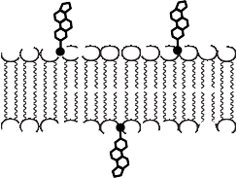
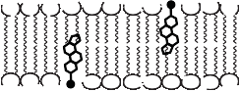
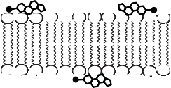
  - The cholesterol forms weak attractive forces with multiple phospholipids in the bilayer. Would this increase or decrease flexibility of the membrane? Explain your reasoning.

Extension Questions
- Embedded proteins are often found spanning the membrane of a cell or organelle. These pro- teins serve as channels for specific molecules to travel through the membrane, either into or out of the cell.
  - What sections of the embedded protein chain are most likely to contain amino acids with hydrophobic R-groups? Explain your reasoning.

  - What sections of the embedded protein chain are most likely to contain amino acids with hydrophilic R-groups? Explain your reasoning.

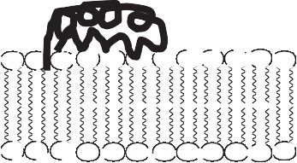
- Some membranes have surface proteins on them. These proteins often serve a signaling func- tion between cells. Propose a mechanism by which these surface proteins are able to attach to the membrane.

